**Advanced Algorithms**

**Exercise for Lecture 5**

|  |  |  |  |
| --- | --- | --- | --- |
| **Student Name** |  | **Student ID** |  |
| **Problem 1** |  | | |
| **Problem 2** |  | | |
| **Problem 3** |  | | |
| **Problem 4** |  | | |
| **Total Score** |  | | |
| **Notes** | Deadline: **2023-09-26 24:00**  Submission Format: ‘**Lecture5_Name_Student ID.docx**’, and please send to: **[algorithms_23fall@163.com](mailto:algorithms_23fall@163.com)**.  This assignment is meant to be an evaluation of your **individual** understanding coming into the course and should be completed **without collaboration** or outside help. | | |

**Problem 1. [25 points]** Draw a binary search tree containing keys $8, 27, 13, 15, 32, 20,$

$12, 50, 29, 11$, inserted in this order. Then, add keys $14, 18, 30, 31$, in this order, and again draw the tree. Then delete keys $29$ and $27$, in this order, and again draw the tree.

**Solution:**

**Problem 2. [20 points]** Given a collection $A$ of numbers and a number $x$, the upper bound of $x$ in $A$ is the minimal value $a∈A$ such that $x≤a$, or NULL if no such value exists. For example, given $A=[7, 20, 1, 3, 4, 3, 31, 50, 9, 11]$, the upper bound of $x=15$ is $20$, while the upper bound of $x=9$ is $9$ and the upper bound of $x=51$ is NULL. Write an algorithm UPPER-BOUND-BST($T, x$) that returns the upper bound of $x$ in a binary search tree $T$. Analyze the complexity of UPPER-BOUND-BST.

**Solution:**

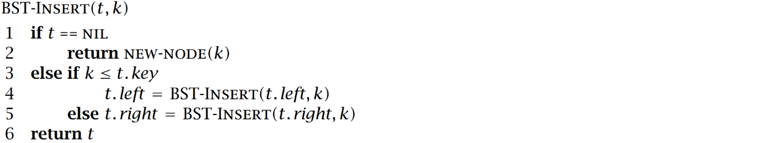**Problem 3. [25 points]** Consider the following classic insertion algorithm for a binary search tree:

Write an algorithm SORT-FOR-BALANCED-BST($A$) that takes an array of numbers $A$, and prints the elements of $A$ in a new order so that, if the printed sequence is passed to BST-INSERT, the resulting BST would be of minimal height. Also, analyze the complexity of your solution.

**Solution:**

**Problem 4. [30 points]** Consider an algorithm BST-FIND-SUM($T, v$) that, given a binary search tree $T$ containing $n$ distinct numeric keys, and given a target value $v$, finds and returns two nodes in $T$ whose keys add up to $v$. The algorithm returns NULL if no such keys exist in $T$. BST-FIND-SUM may not modify the tree, and may only use a constant amount of memory.

1. Write BST-FIND-SUM($T, v$). You may use the basic algorithms that operate on binary search trees (TREE-MINIMUM, TREE-SUCCESSOR, TREE-SEARCH, etc.) without defining them explicitly.
2. Write a variant of BST-FIND-SUM($T, v$) that works in $O(n)$ time. If your solution to *Exercise a* already has this complexity bound, then simply say so.

**Solution:**